Roll No.:2503a52531
Name:B.Poojitha
Batch:18
Question 4. Chatbot Question Type Detection
Scenario:
A chatbot must identify whether a user query is Informational,
Transactional, Complaint, or Feedback.
Tasks:
1. Prepare 6 chatbot queries mapped to question types.
2. Design prompts for Zero-shot, One-shot, and Few-shot learning.
3. Test all prompts on the same unseen queries.
4. Compare response correctness and ambiguity handling.
5. Document observations.

Prompt for ZERO-SHOT:
Classify the chatbot question into exactly one category:
Informational
Transactional
Complaint
Feedback
Informational: Asking for information.
Transactional: Requesting an action or change.
Complaint: Expressing dissatisfaction or reporting a problem.
Feedback: Giving an opinion, suggestion, or positive comment.
Question:
{question}
Return only the category.

Code for ZERO-SHOT:
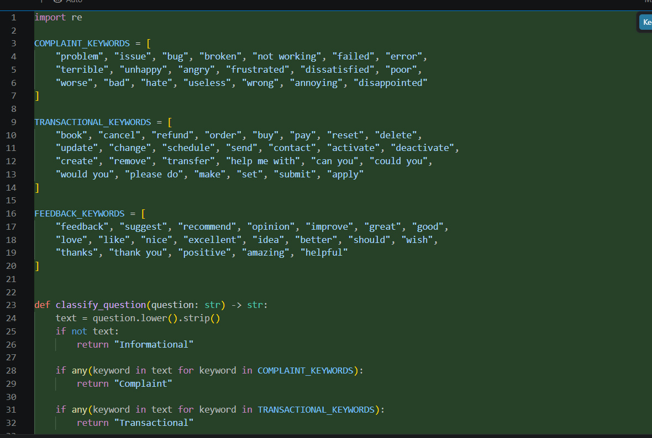
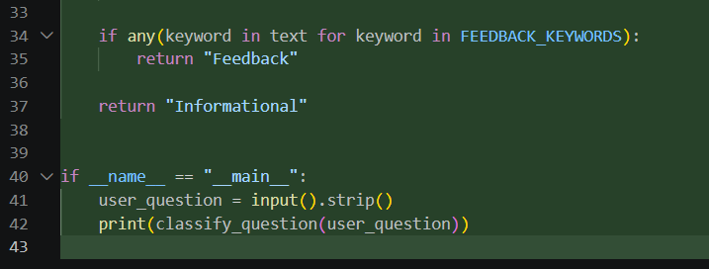

Output:
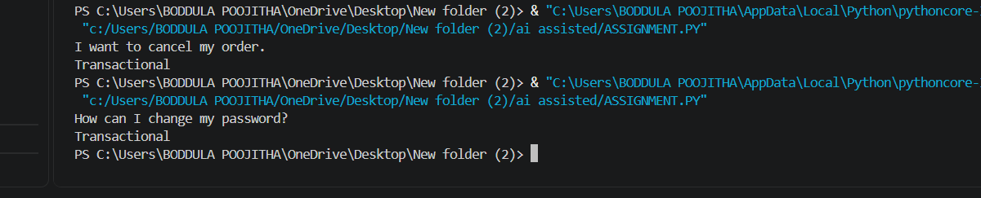

Prompt for ONE-SHOT;
Classify chatbot questions into Informational, Transactional,
Complaint, or Feedback.
Example:
Question: What are your customer support timings?
Type: Informational
Now classify:
Question:
{question}
Return only the category.

Code for ONE-SHOT:
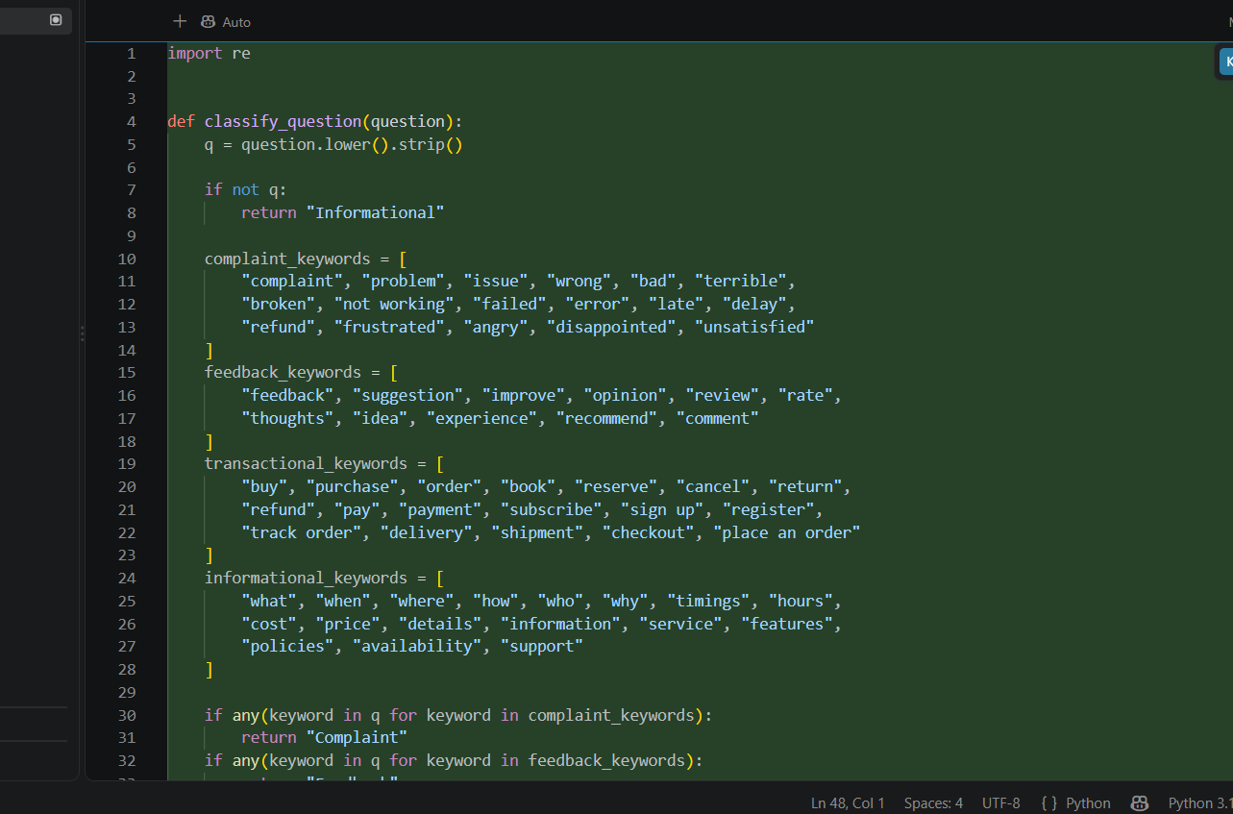
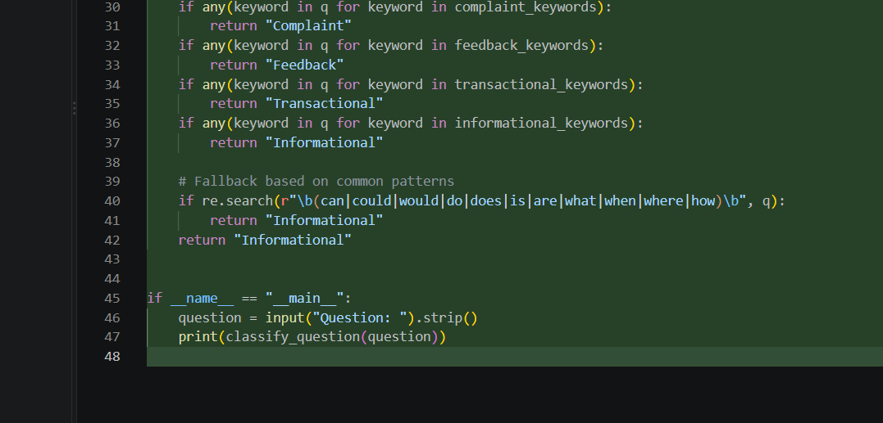

Output:
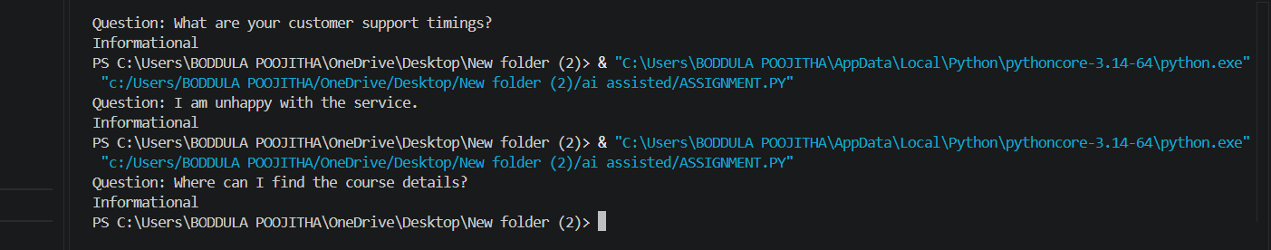

Prompt for FEW-SHOT:
Classify chatbot questions into four categories.
Example 1:
Question: What are your customer support timings?
Type: Informational
Example 2:
Question: I want to cancel my order.
Type: Transactional
Example 3:Question: I am unhappy with the service.
Type: Complaint
Example 4:
Question: The new update is very useful.
Type: Feedback
Now classify:
Question:
{question}
Return only the category.

Code for FEW-SHOT;
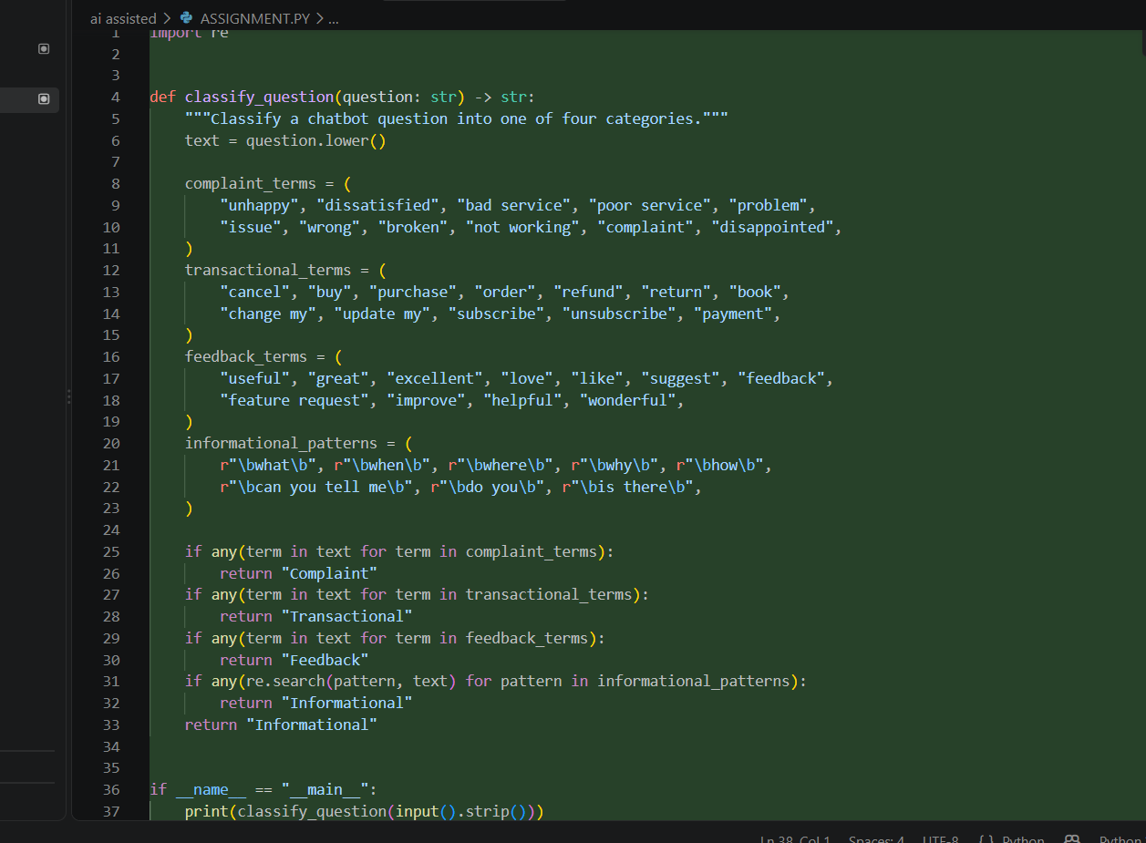

Output:
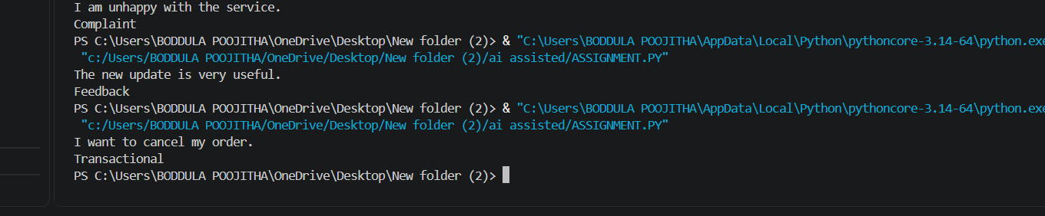

Observation;
1. Zero-shot prompting can classify simple chatbot questions into Informational, Transactional, Complaint, or Feedback.
2. It may sometimes confuse Complaint and Feedback because both can express opinions or experiences.
3. One-shot prompting provides one labeled example, helping the model understand the expected classification.
4. Few-shot prompting provides examples for all four categories, resulting in better and more consistent classification.
5. Informational questions generally ask for details or explanations, while transactional questions usually request an action.

